**Case Study on Multi-Core Processors**

**THEORY:**

**Introduction to Multi-Core Processors:**

A multi-core processor is a single [computing](https://en.wikipedia.org/wiki/Computing) component with two or more independent [processing units](https://en.wikipedia.org/wiki/Central_processing_unit) called cores, which read and execute [program instructions](https://en.wikipedia.org/wiki/Instruction_set). The instructions are ordinary [CPU instructions](https://en.wikipedia.org/wiki/Instruction_set) (such as add, move data, and branch) but the single processor can run multiple instructions on separate cores at the same time, increasing overall speed for programs amenable to [parallel computing](https://en.wikipedia.org/wiki/Parallel_computing). Manufacturers typically integrate the cores onto a single [integrated circuit](https://en.wikipedia.org/wiki/Integrated_circuit) [die](https://en.wikipedia.org/wiki/Die_(integrated_circuit)) (known as a chip multiprocessor or CMP) or onto multiple dies in a single [chip package](https://en.wikipedia.org/wiki/Chip_carrier). The microprocessors currently used in almost all personal computers are multi-core.

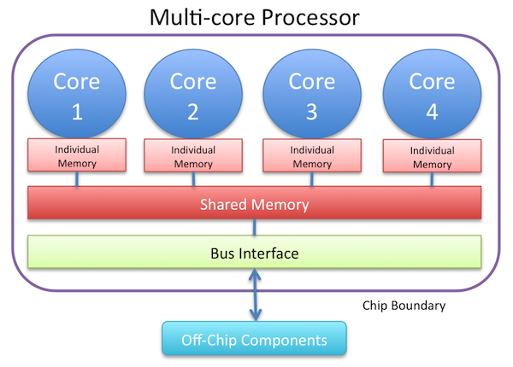

FIGURE 1: BLOCK DIAGRAM OF GENERIC MULTI CORE PROCESSORS

**Attributes:**

1. They can physically run multiple threads of the same process, and/or multiple processes at the same time.
2. Multi-core processors can deliver [significant performance benefits for multi-threaded software](https://searchservervirtualization.techtarget.com/tip/The-reality-of-processor-performance-improvement-with-hyperthreading) by adding processing power with minimal latency, given the proximity of the processors.
3. The proximity of multiple CPU cores on the same die allows the [cache coherency](https://en.wikipedia.org/wiki/Cache_coherency) circuitry to operate at a much higher clock rate than what is possible if the signals have to travel off-chip.

**Characteristics:**

* Higher efficiency
  + Split Load means quicker production times
  + 4 cores running low optimization is much better than 1 core doing overtime or 2 cores running full force
  + As such, power consumption will be down
* They are great for gaming with CPU intensive titles
* Larger Cache’s relatively speaking
* In terms of lower level microprocessors, having a multi-core processor generally gives you more I/O as more things can be done in parallel
* Many applications can take advantage of the multiple cores to run faster

**Features of i3 Processor:**

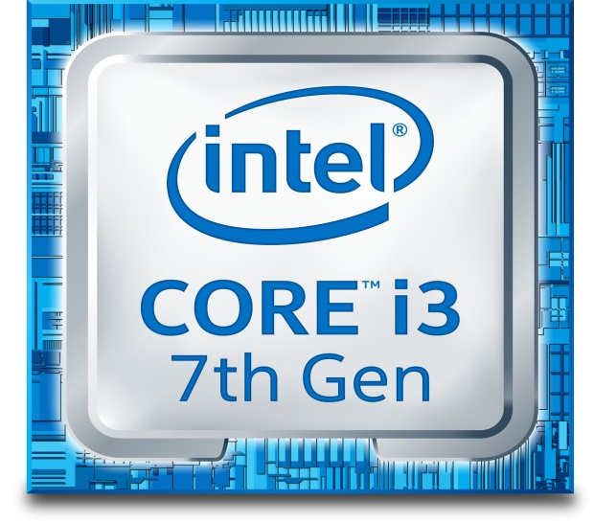

FIGURE 2: Intel core i3 7th Generation

* Intel core i3 can perform hyper threading meaning it can multi-task without taking much of your ram which makes lag free to use
* It has multiple threads and virtual cores which boosts per second that makes your pc blazing fast.
* Developed and manufactured by [Intel](https://www.computerhope.com/comp/intel.htm), the Core i3 is a dual-core computer processor, available for use in both desktop and laptop computers.
* It is one of three types of processors in the "I" series (also called the Intel Core family of processors).
* The Core i3 processor is available in multiple speeds, ranging from 1.30 GHz up to 3.50 GHz, and features either 3 MB or 4 MB of [cache](https://www.computerhope.com/jargon/c/cache.htm).
* It utilizes either the LGA 1150 or LGA 1155 socket on a [motherboard](https://www.computerhope.com/jargon/m/mothboar.htm). Core i3 processors are most often found as dual-core, having two cores. However, a select few high-end Core i3 processors are quad-core, featuring four cores.

. 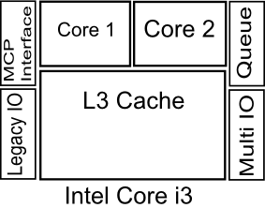

FIGURE 3 : BLOCK DIAGRAM i3 processor

**Features of i5 Processor:**

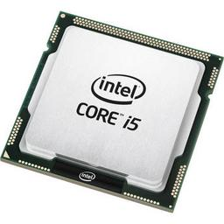

FIGURE 4: INTEL CORE i5

* The Core i5 processor is available in multiple speeds, ranging from 1.90 GHz up to 3.80 GHz, and it features 3 MB, 4 MB or 6 MB of [cache](https://www.computerhope.com/jargon/c/cache.htm). It utilizes either the LGA 1150 or LGA 1155 socket on a [motherboard](https://www.computerhope.com/jargon/m/mothboar.htm).
* Core i5 processors are most often found as quad-core, having four cores. However, a select few high-end Core i5 processors feature six cores.
* The most common type of [RAM](https://www.computerhope.com/jargon/r/ram.htm) used with a Core i5 processor is DDR3 1333 or DDR3 1600, however, higher performance RAM can be used as well (if the motherboard supports it).
* .i5 provides the opportunity to the users to use the system with multi-tasking.i5 processor are also able to increase the memory of the system and help users to work with the high bandwidth and great performance.
* A big feature of the i5 processors is that they have ability to run two multitasking processors together that are generally called as dual processors and can increase the working performance of the system efficiently.
* Turbo boost technology of i5 processors is the key beneficial feature of the i5 processors that allow the users to do their regular and important working with the help of heavy applications.

**Features of i7 Processor:**

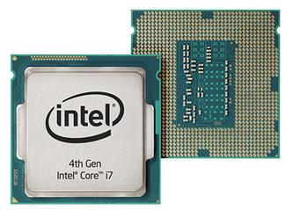

FIGURE 5: INTEL CORE I7 4TH GENERATION

* In i7 processors users can enjoy the high speed working with the additional feature of the multitasking i.e. using two different documents or the files at the same time.
* [Dual core technology](http://wifinotes.com/computer-hardware-components/working-of-dual-core-processors.html) is also a part of i7 processors that provide reliable and high data rate working performance to the customers.
* A big feature of the i7 processors is the Turbo Boost technology. This technology provides the high performance to the system to the users to overcome the work load of different applications on the system and maintain the speed of the system.
* Like i5 and i3 processors, i7 also have a feature of Hyper threading technology enhances the activity and the speed of the system by managing the multitasking, work load and different types of heavier applications of the users.
* i7 processors are so advanced to deals with the integrated memory of e system and have ability to increase the memory up to 1066 MBits and provide the working speed of 25.6 GB/sec.

**Difference Between i3, i5 and i7 Processors:**

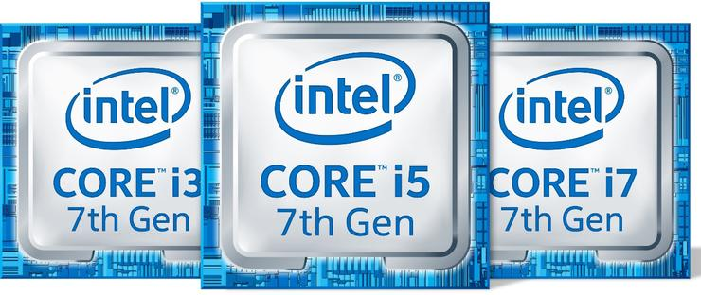

FIGURE 5: INTEL CORE PROCESSORS

* Number of Core: The Core i3 range is entirely dual core, while Core i5 and i7 processors have four cores.
* Clock Speed : The i3 core processor has clock speed range of 3.4GHZ - 4.2GHZ whereas the i5 core processor has the clock speed range of 2.4GHZ - 3.8GHZ lastly the i7 core processor has the clock speed range of 2.9GHZ - 4.2GHZ.
* Turbo Boost : The i3 core processor does not have this turbo boost technology while both i5 and i7 have turbo boost technology.
* Cache Memory: Intel i3 core processor has cache memory of 3-4 Mb ,Intel i5 core processor has cache memory of 4-6Mb,Intel i7 has cache memory of 8Mb.
* Hyper Threading : Intel i5 does not have hyper threading but both Intel i3 and Intel i7 has hyper threading technology

**CONCLUSION:**

In this experiment we learnt about multi core processors. We learnt how number of cores in processors make difference in performance .We also saw the difference between Intel core i3,i5 and i7 processors. More the cores we have more the tasks can be performed smoothly and efficiently. Multitasking becomes possible using multi core processors.